**SQL Assignment 3**

1. **Create a function and then call another function from within it. What is this process called?**

* The stored procedure is SQL statements wrapped within the **CREATE PROCEDURE** statement. The stored procedure may contain a conditional statement like IF or CASE or the Loops. The stored procedure can also execute another stored procedure or a function that modularizes the code.
* Create Procedure [Procedure Name] ([Parameter 1], [Parameter 2], [Parameter 3])  
  Begin  
  SQL Queries  
  End
* The name of the procedure must be specified after the **Create Procedure** keyword
* After the name of the procedure, the list of parameters must be specified in the parenthesis. The parameter list must be comma-separated.
* The SQL Queries and code must be written between **BEGIN** and **END** keywords

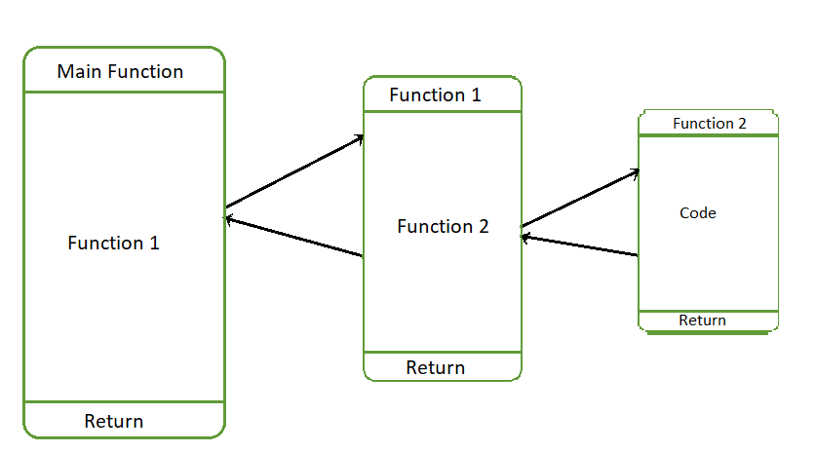

1. **How to inspect the query’s execution plan?**

* A query execution plan can also be captured in a SQL Server trace and opened in SQL Server Profiler
  1. Start SQL Server Profiler.
  2. In the **File** menu, select **New Trace.**
  3. In the **Events Section** tab, check **Show all events.**
  4. Expand the **Performance** node.
  5. Select **Showplan** XML.
  6. Execute the query you want to see the query plan for.
  7. Stop the trace. This is recommended due to practical reasons – in busy databases, it’s difficult to filter by the event you want to trace.
  8. Select the query plan in the grid.

1. **What is the purpose of the MAXDOP and recompiling keywords in SQL queries?**

* The maximum degree of parallelism (MAXDOP) is a server configuration option for running SQL Server on multiple CPUs. It controls the number of processors used to run a single statement in parallel plan execution. The default value is 0, which enables SQL Server to use all available processors. This can affect performance and isn’t optimal for most use cases.

1. **How to build DDL statements from an existing database table, write steps for it?**

* A copy of an existing table can be created using a combination of the CREATE TABLE statement and the SELECT statement. The new table has the same column definitions. All columns or specific columns can be selected. When you will create a new table using the existing table, the new table would be populated using the existing values in the old table.
* Syntax:

CREATE TABLE NEW_TABLE_NAME AS

SELECT [ column1, column2...column]

FROM EXISTING_TABLE_NAME

[ WHERE]

1. **How to update data in a table using an inner join, write an example?**

* Let us take an example of a customer table. I have updated customer table that contains latest customer details from another source system. I want to update the customer table with latest data. In such case, I will perform join between target table and source table using join on customer ID.
* **SYNTAX:**

**UPDATE** customer_table **INNER JOIN** Customer_table ON customer_table.rel_cust_name = customer_table.cust_id

**SET** customer_table.rel_cust_name = customer_table. cust_name

**Q6) Differentiate between truncate, delete, and drop with a suitable example.**

### ****1. DELETE :****

Basically, it is a [Data Manipulation Language Command (DML)](https://www.geeksforgeeks.org/sql-ddl-dql-dml-dcl-tcl-commands/). It is used to delete one or more tuples of a table. With the help of the “DELETE” command, we can either delete all the rows in one go or can delete rows one by one. i.e., we can use it as per the requirement or the condition using the Where clause. It is comparatively slower than the TRUNCATE command. The TRUNCATE command does not remove the structure of the table.

* **SYNTAX –**   
  If we want to delete all the rows of the table:

DELETE from;

* **SYNTAX –**   
  If we want to delete the row of the table as per the condition then we use the WHERE clause,

DELETE from WHERE ;

**Note –** Here we can use the “ROLLBACK” command to restore the tuple because it does not auto-commit.

### ****2. DROP :****

It is a Data Definition Language Command (DDL). It is used to drop the whole table. With the help of the “DROP” command we can drop (delete) the whole structure in one go i.e. it removes the named elements of the schema. By using this command the existence of the whole table is finished or say lost.

* **SYNTAX –**   
  If we want to drop the table:

DROP table ;

### Note – Here we can’t restore the table by using the “ROLLBACK” command because it auto commits.

### 3. TRUNCATE :

It is also a Data Definition Language Command (DDL). It is used to delete all the rows of a relation (table) in one go. With the help of the “TRUNCATE” command, we can’t delete the single row as here WHERE clause is not used. By using this command the existence of all the rows of the table is lost. It is comparatively faster than the delete command as it deletes all the rows fastly.

* **SYNTAX –**   
  If we want to use truncate :

TRUNCATE;

**Note –** Here we can’t restore the tuples of the table by using the “ROLLBACK” command.